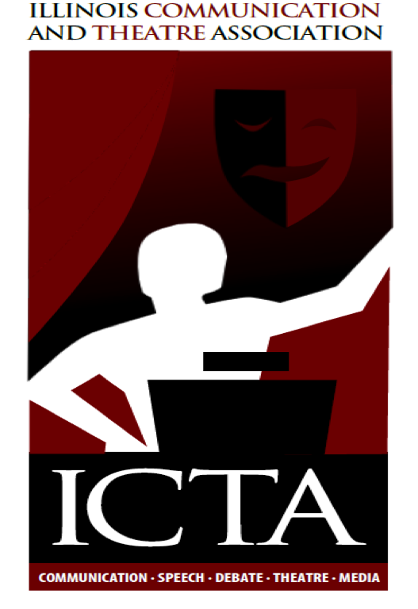
Illinois Communication and Theatre Association
Annual Meeting
Theatre Commissioner’s Report

- At the beginning of planning for this year’s convention, I sent out facebook and email requests asking for people who would be willing to help create panels or serve on them. The first time I sent these requests, I received very few responses. I then sent out a second request with a little more humor and received several responses from people willing to create and serve on panels. Thank you to Allan Kimball, Tom Dzurison, Ross Wheeler, Elizabeth Wheeler, Lauren Rodriguez and Lisa Ramos
- The Theatre Sessions will cover a large variety of issues including: building sets in difficult situations, using theatre in the classroom to help with creative thinking and teaching the common core, and using Devised Theatre Production to help students create socially responsible performances.
- As the time for convention drew closer, several people had to withdraw their help because of conflicts with time and finances. Some simply did not get back to me. I’m very thankful for the ones who were able to follow through and were happy to help wherever they were needed.
- In an attempt to recruit new members to ICTA, I asked several people that were not current members if they would be willing to present at the convention. I don’t know what we can do to help these professionals convince their administrators that our convention is valuable, but I do know that they need help to get the support they need from the people in charge of their schools.

