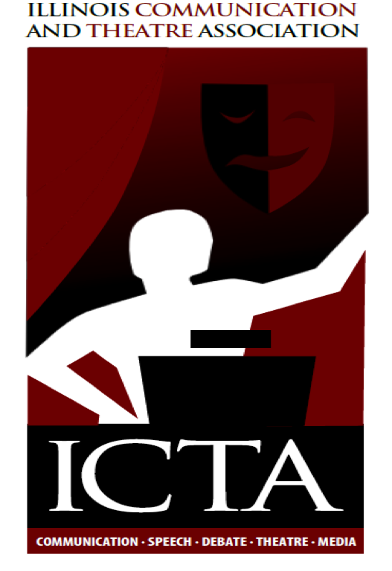
Illinois Communication and Theatre Association
Annual Meeting
President Elect’s Report – Submitted by Kevin Long

The bulk of my work this year has been on planning our annual convention. Planning a convention is quite a difficult and daunting task; however, I felt the strong support of the board (both morally and action based) which made me feel more comfortable and more confident as I met this challenge for the first time. I am truly thankful for their help.

- The theme of “What If” came about as we are currently navigating our way through addressing the Common Core State Standards as well as the importance of the communication arts in the training and educating of our future teachers at all levels. Through our gathering this weekend, I hope that the “What ifs” we address will inspire conversations and spark ideas that will help enhance the understanding of our profession and support meaningful professional development for all who attend. I also hope that you might consider taking a more active role in the ICTA - your state’s communication organization. We need you. “If” makes anything possible!
- Doug Jennings, Rich Jones, Ellie Marvin, Julie Weishar Tina Winings, and Anna Wright were instrumental in helping me to organize and plan the convention. I am deeply grateful for their help, hard work, and support.
- In preparing for the convention, I standardized the workshop/presentation proposal submission procedures. This enabled the planning committee to effectively assess and program convention sessions. I then sent out confirmation, via e-mail, to each confirmed presenter. This process worked well as we had a number of panel submissions covering a wide range of topic areas for both secondary and higher ed.
- When I began planning my convention, I presented the board with a detailed proposed budget. My goal has been to present a meaningful convention while holding to the proposed budget. This transparency helped to keep the convention on target.
- Holding a convention in the Chicago area is typically more expensive because of the location. Julie Weishar’s efforts to reach out to textbook representative and secure sponsorships was a tremendous help in keeping the convention within budget. Please look at the program as you will see sponsorships for our lunch and breakfast meals. The final page of the program highlights the companies who have provided financial support for the convention. Thank you Julie! Please return the favor by promoting and supporting our gracious sponsors.
- Rich Jones worked hard to update our new website by placing convention information as well as making it possible to pay for annual memberships and convention fees via the site. Thank you Rich.

As I transition into the role of president, I would like to thank Ellie Marvin for her advice and guidance throughout this process. I would like to increase our presence via our website and other forms of social media. ICTA is the professional organization in Illinois for communication, theatre, debate, forensics and media for secondary and higher education. Our membership consists of professionals with keen knowledge, wisdom, expertise, and experience in the communication arts. We as a group can influence conversations and decisions made at the local and state level. It’s important that our voice is heard. I would also like to help Adam Jenkins in any way I can as he prepares for the 2015 Annual Convention.

“Your If is the only peacemaker” – Touchstone, As You Like It

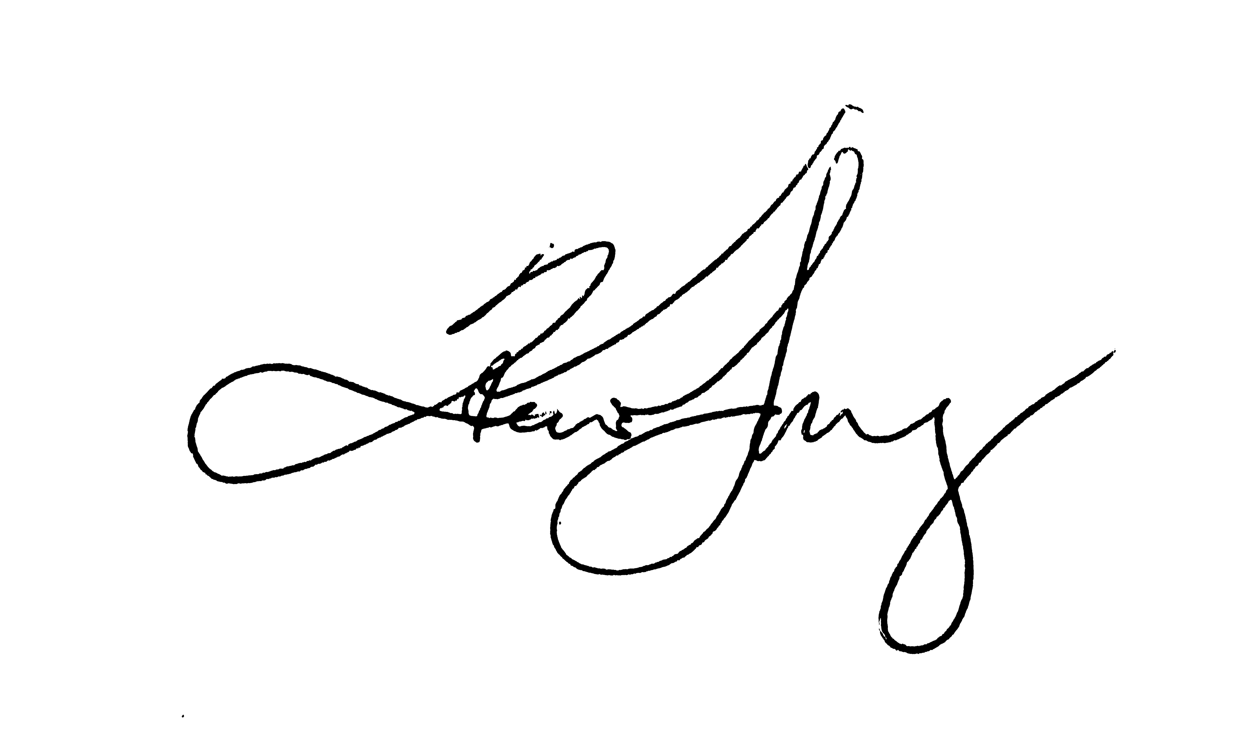
My very best regards,

KEVIN LONG
Director of Theatre | Assistant Professor
www.kevinlongdirector.com | http://bcove.me/919rgsby
Harper College| 1200 W. Algonquin Road | Palatine, IL | 60067
847.925.6944 | www.harperspeech.net
