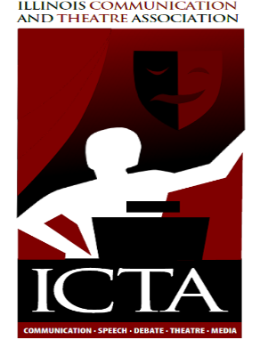

Higher Education Chair – Annual Report, 2014
As I reflect back on my first year on the board of directors for ICTA, I am pleased by the work that we have done collectively. I believe that the board’s success is interdependent with the success of the membership and I know that our members are accomplishing great things and succeeding in many ways. I also value feedback and invite any member to contact me with feedback, ideas, suggestions, or concerns.
The following lists the accomplishments and activities of the previous year:
- I attended all board meetings and the convention planning meeting. I also served on the Awards Review Committee and the Constitution, Bylaws, Policy Manual Revision Committee. I am also temporarily serving as the webmaster for the organization.
- Colleagues in higher education were contacted and informed about ICTA’s initiative to reestablish teaching endorsements for oral communication.
- A one day “Communicator’s Conference,” sponsored by ICTA and the Department of Communication Studies at Eastern Illinois University, was held on Eastern’s campus on April 11, 2014. There were 11 attendees, five sessions, and eight presenters.
- The call for papers/proposals for the 2014 conference was shared with colleagues in higher education.
- Higher education submissions and proposals were evaluated, resulting in five panels and six posters in this year’s program.
- New awards for top submissions were established and will be given out at this year’s convention. Each award winner received a certificate and $50.
Respectfully submitted,
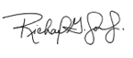
Richard G. Jones, Jr., Ph.D.
Assistant Professor and Basic Course Director
Communication Studies
Eastern Illinois University

