Sponsorship Form
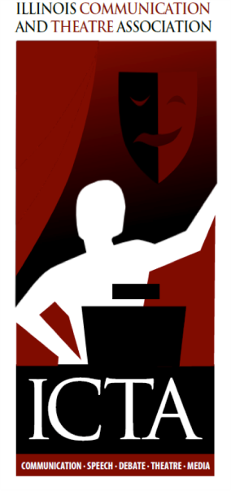 | 2018 Convention - Sept. 27-29  DoubleTree by Hilton Hotel  10B Brickyard Drive  Bloomington, Illinois, 61701  “Roots, Renaissance, Revolution!”

Sponsorship Levels (check desired level):
Platinum | $1,000 minimum
Gold | $750.00 minimum
Silver | $500.00 minimum
Bronze | $200.00 minimum
Booth space | $50.00 (free with bronze level or above)

Sponsorship Opportunities
Keynote Speaker $____________________
Conference food items (indicate item you would like to sponsor):

New Member Reception

Friday Luncheon

Friday or Saturday breakfast

New Coach Workshop
Convention giveaways – Items: _________________________________________________________
Ad space in the conference program _____$50.00 (full page ad) _____$25.00 (half page ad)
Ads are free with sponsorship at the bronze or higher level

Ad space in a tri-annual newsletter _____$30.00 (full page ad) _____$15.00 (half page ad)
With platinum sponsorship, ad is free in two newsletters; with gold, ad is free in one newsletter.

Acknowledgement Information
Company name and contact information:
e-mail copy of ad to amwrigh@ilstu.edu by September 1, 2018 OR
Mail hard copy to: Anna Wright, Illinois Communication and Theatre Association, School of Communication, Campus Box 4480,Illinois State University, Normal, IL 61790-4480
Sponsors receive acknowledgment in the program and at the convention.

